FEC Filing Process “Abstract Level” :

0. Process Data Center Merges

16th:
1. Import Direct Mail Donations ( & negatives)

2. Import On-Line Donations

3. Import On-Line Earmarks

3. Import Joint Fundraising Attributables

4. Run Import check script (should be 0 rows returned).

17th:
5. Change all CM & PT-coded transactions to “deposited” status.

6. Change NT codes (earmarks) to CN. [this step may be temporary].

7. Clear ASCII Code 10 and 13 (Line feeds/carriage returns) from all fields to prevent report errors.

8. Update note field for Unlimited Transfers.

9. Check “sPeriod – sCycle” pairs (Should appear for all CMs & CNs). Other transactions should have sCycle, but not sPeriod.

9. Match child PT status to parent status & Check for “orphan” PTs.

10. Report all “non-deposited” transactions to Accounting. Report CMs & CNs. Report unlimited transfers. Report On-Line & DM Negatives.

18th:
11. Use “Reports -> FEC Report” to generate file for FEC.

12. Change sNote for LLCs to “better language”.
FEC Process “Detail Level” – Step 1: Importing Direct Mail Records

Direct mail donations are recorded & delivered to us from the various vendors that we retain contracts with. (1) Upon receipt of these records, they are “cleaned up” slightly through a process that is currently in an Access database (the database is currently found at \\d3cfile01\IT\db1.mdb ). This cleaning process updates the following aspects of the data (mostly centered around alleviating ambiguities in occupation & employer fields) : Changing “Housewife” to “Homemaker”, “Lawyer” to “Attorney”, Employer to “N/A” and Occupation to “Retired” for any form of “Retired” in occupation, “Self” or “Self Employed” to “Self-Employed” in the employer field, and blanking out Occupation and setting Employer to “Self-Employed” where Occupation is any form of “Self Employed”.

After the records are cleaned, they are pre-processed and parsed for entry into the NGP Financial database. This is done through the following steps (currently the pre-processing stage is handled through VBA programming attached to an Excel sheet):

(2) Records are imported as text into the pre-processing sheet. It is important to preserve the text of the records so that leading “0”s on zip-codes and cents on currency fields are not obscured by Excel. This is currently set up to run through a “query” that automatically refreshes with a file that the user can specify when the sheet is opened.

(3) Contribution_account and Contribution_source codes are added to every record. This is fairly straightforward – it is currently handled by a simple VBA routine that appends them to every record on the rightmost “unused” columns, but it could just as easily be done by dragging them down the respective columns. The source code for DM is “YY” and the account code for DM is “800”.

(4) Records are tagged with their NGP Count of VendorID and parsed from each other based on the result. This is an important step that greatly reduces the number of duplicate records that are created as a result of the import process. It is currently handled by the CheckIDs() routine in the VBA programming. The CheckIDs routine, described informally, checks the vendorID for each record in the import ( The routine assumes that the VendorID is found in the first column – this must be true for CheckIDs to run ) and adds to the last field of each record an integer value indicating how many NGP records share the incoming record’s vendorID. In most cases, the number will be 0, 1, or 2 (the 2’s are a result of errors in the old financial system that slipped by undetected for a long period of time. It is hoped that over time, the number of these that appear in imports will be reduced.). From this point the records should be sorted, separated and handled differently according to this value.

(5) Match-merging the “zeros” into NGP. If the record is a “zero” record (w.r.t. VendorID), then we know that there are no NGP records that have a matching VendorID, so we need to run our match-merge based on other criteria; Currently we use the NGP match-merge key “Lastname, Firstname, City, State” for this purpose (assuming that if someone has the same name, in the same city then we are using our “best efforts” to match them up with records already in our system). See the detail section 8 on “NGP Match-Merging” a few paragraphs down for more instructions on how to handle the imports through NGP’s interface.

(6) Match-merging the “ones” into NGP. Of the three groups, this is the most straightforward to import. Since we know that NGP has one and only one record with the same VendorID, we can safely match-merge these on the “VendorID” key. Since DM doesn’t use NGP for its CRM functions, we don’t need to concern ourselves too much if they happen to change contact information on the DM end. Although, it would be helpful for “best efforts” to pick out and update records with non-matching information once or twice per year.

(7) Match-merging the “>1”s into NGP . This grouping requires the most “overhead time” to process, but each time it is done, the number of them in the next import will be reduced. In terms of “match-merging” this group is similar to the “1”s (use the VendorID key), except that before you match-merge you should go through the records in NGP and for each pair of records with a given VendorID, NULL out the VendorID on the one that is most unlike the one on your DM import sheet. (e.g. if we have a vendorID 73 on the import sheet, look at the records in NGP with VendorID = 73. If your import sheet has “Jon Doe” as the contact, and the two records in NGP are “Jane Doe” and “Jon Doe”, set “Jane Doe”’s VendorID to <NULL>).

(8) [General description of how to use NGP’s Match-Merge interface]

a) All transactions have to have a valid, open batch. So the first thing we have to do is create a batch for our DM records. Do this by going into the “tools -> financial batch manager”. Then hit the “Add New Batch” button. The number for the batch should be in the form “YYMMDD800”.

b) Open the import manager: File -> Imports -> Import Data

c) Save your groupings as CSVs (they tend to work better with the imports).

d) Change “Filetype” to CSV and point to the file with the “Browse” dialog.

e) Set “Code for Each Contact” to CAT – DM. (This marks the main record as a DM donor)

f) Use the “Custom” mapping option.

g) Default contact type I

h) Check the “import type” checkbox to indicate that you are importing transactions.

i) Change the match-merge dropdown to the type indicated in step 5, 6, or 7 (depending on which group you are importing)

j) Change the “Batch” field under “Contribution Defaults” to be the one that you made in step a.

k) Change the “Contrib Status” to “Deposited”

l) Hit the “MAP” button,

m) Double-check to see that your “Sources” map correctly to their “Destination” (be careful to manually map contrib._source and contrib_account if you didn’t name them “contrib._source” and “contrib_account” in your sheet.)

Here is a screenshot of what it should look like before you hit “Import” :

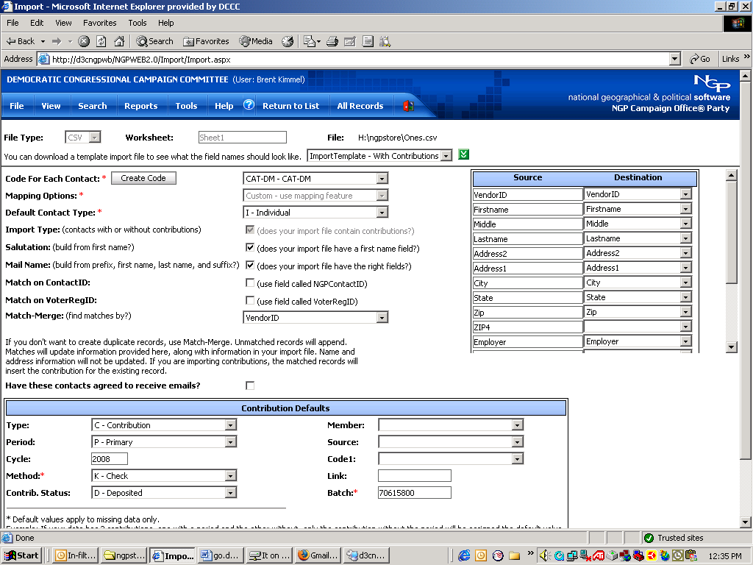

m) Hit “import”.
FEC Process “Detail Level” – Step 2: Importing On-Line Donations

On-Line donations are delivered via email through scripts created by the On-Line department. Typically, we will receive two “positive” files (“positive” w.r.t. amount), one for domestic donors and one for international. They are handled in essentially the same way, through a process that is very similar to the DM one. (All of the preprocessing is done through VBA code in the Excel sheet.)

(1)As with DM, the process begins by importing the records as text into the pre-processing sheet.

(2)Add account and source codes to each record. (Account and source for On-Line are “135” and “208” respectively.) This can be done through the FillAccountCodes() sub-routine in the pre-processing sheet.

Now, like DM, we parse the records based on how many VendorID2s for a particular record already exist. However, because of an idiosyncrasy with the way that On-Line stores & reports information about donors, a matching VendorID2 is no guarantee that an incoming record is a “good match” with what is already in NGP. Because of this, our parsing logic has to go a little bit deeper; So we check for both a matching ID and a “close enough” match on the last and first name. We define “close enough” as having the same last name and the same first letter of the first name. We store both of these results in separate columns and use them to parse the incoming records from each other and process them accordingly.

(3)[All of that is encompassed by running “DoItAll()” in the sheet.]

On-Line Import Cases:

(Vector 1 is the VendorID2 count, Vector2 is the IDCount with the added restriction of a “good enough” name match)

Vector1 Vector2 Case#
0 0 0
0 1 1 (Impossible since Vector2 is a more restrictive query)
1 0 2
1 1 3 (Good enough match on name and VendorID2)

Case #0: 0 0
These records can be safely assumed not to have a matching record in the NGP system. They should be match-merged on the key Lastname, Firstname, City, State.

Case #1: 0 1
(Not possible, see above)

Case #2: 1 0
This is the “problem case” - Although there are typically very few of these, records in this case have the potential to cause problems because they have a matching VendorID2, but the name with that ID in NGP isn’t a “Good enough” match with the incoming record. It is always safe to move all of them into Case #0, and you should do this if you don’t have time or there are too many to manually process – Assuming that no one has changed their information in the NGP system, they will not be duplicated most of the time because once they are entered into NGP, you can always match-merge to that record again when necessary based on city, state, etc. When you move Case 2 records into case 0, always remember to strip out their VendorID2 – forgetting to do this will jeopardize the uniqueness of the VendorID2 in NGP. (At some point, if there are ever an unmanageable number of these, it may be productive to create a system on the side to ensure “perfect matches”.) If you have the time, it is helpful to go through the records in this case and push as many of them as possible into case #3 (especially in cases where Vector2 came up zero because a ‘B’ in Bill doesn’t match the NGP record of ‘W’ for William as an example.) . Match-merge the records in this case based on which case you move them in to.

Case #3: 1 1
Clean match on VendorID2 and “Good enough” match on the name that goes with it. Just match-merge these on VendorID2.

Use “CAT-WEB” for the code in step e) of the above instructions, otherwise they are the same.
FEC Process “Detail Level” – Step 3: Importing On-Line Earmarks

Importing “Earmarked” contributions from On-Line is almost identical to importing regular On-Line contributions - in fact, it is done through the same pre-processing sheet, but it does require a few extra steps and resources, as outlined below:

1) Convert FEC notes from “STDI” format to “CandidateName (ST-DI)” format through lookups, and be careful to catch and update any that don’t match. This is currently done through the ConvertNotes() VBA subroutine - note that the subroutine requires the STDI to be in the last field.

2) Use the “FillEarmarkCodes” instead of “FillAccountCodes” sub.

